**6G.SAI MAHESH**

**192211122**

1. Configuration of Network Devices using Packet Tracer tools (Hub, Switch, Ethernet, Broadcast)

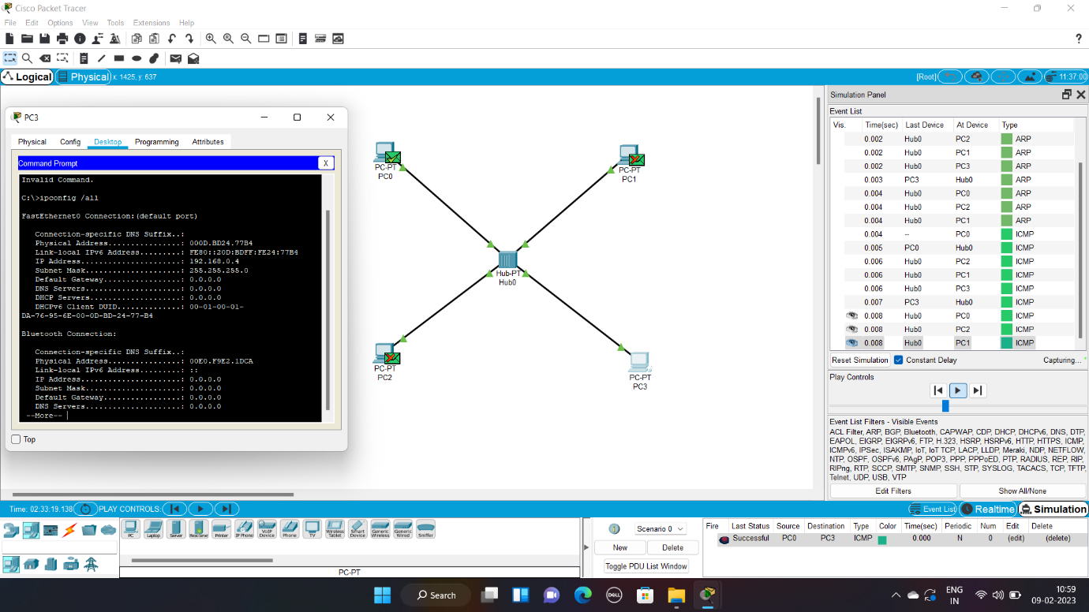

192211122

2. Design and Configuration of Star Topologies using Packet Tracer

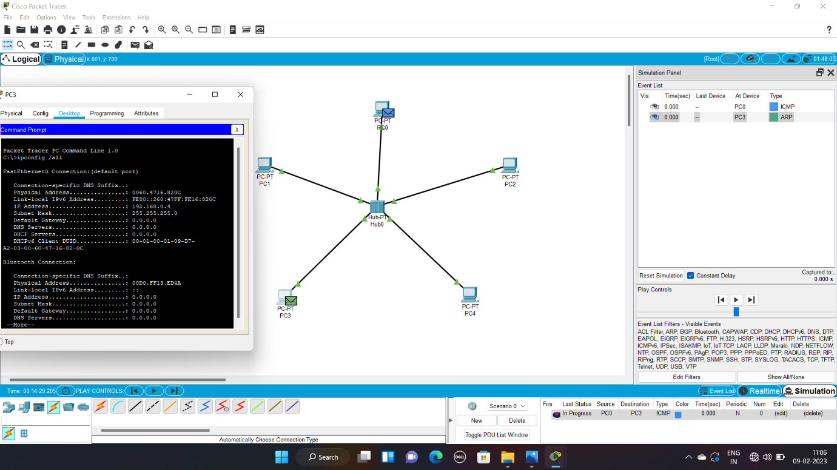

192211122

3. Design and Configuration of BUS Topologies using Packet Tracer

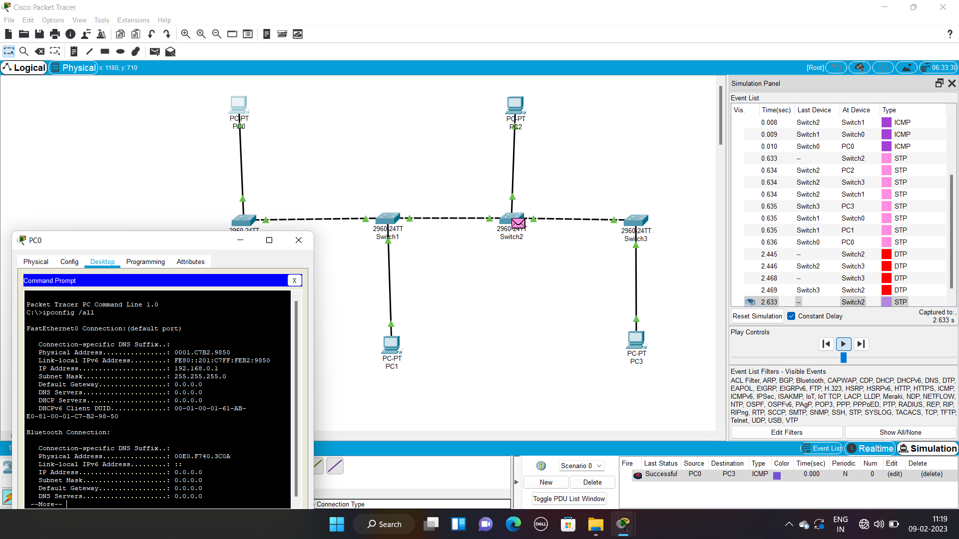

192211122

4. Design and Configuration of RING Topologies using Packet Tracer

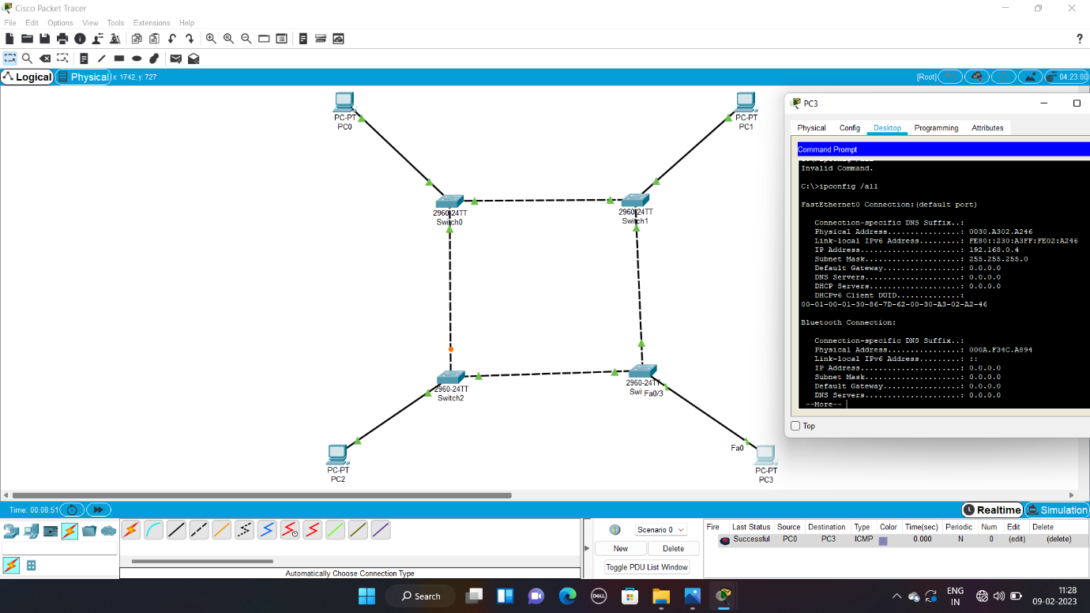

192211122

5. Design and Configuration of Mesh Topologies using Packet Tracer

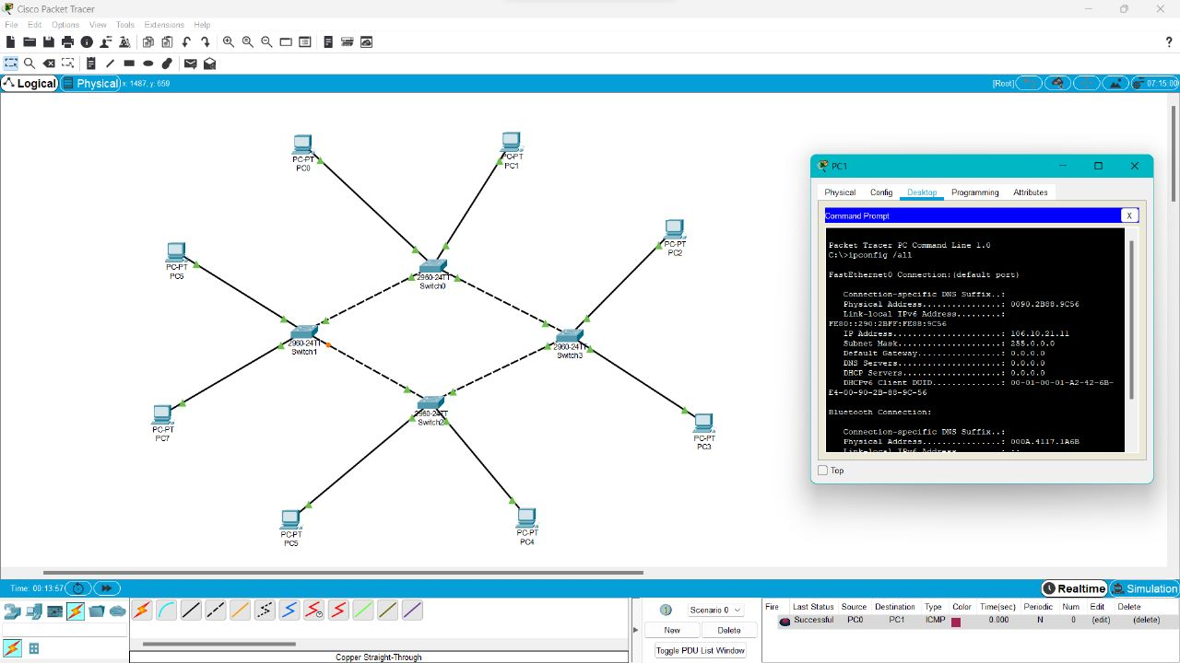

192211122

6. Design and Configuration of Tree Topologies using Packet Tracer

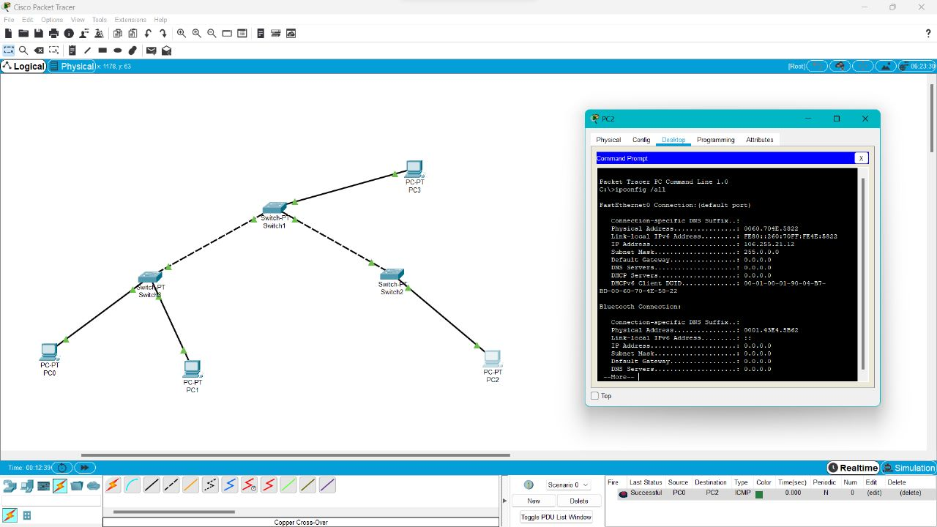

192211122

7. Design and Configuration of Hybrid Topologies using Packet Tracer

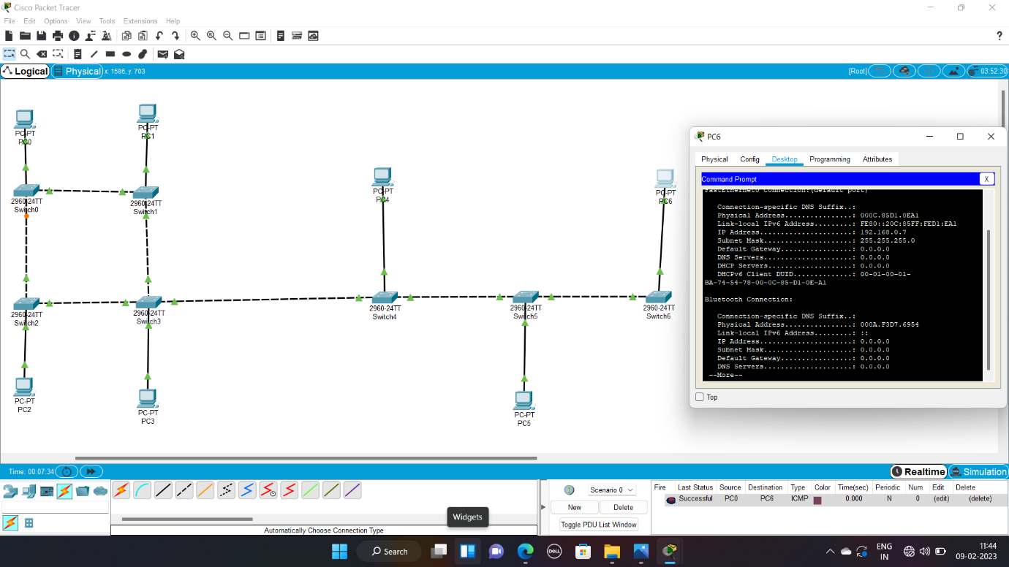

192211122

8. Data Link Layer Traffic Simulation using Packet Tracer Analysis of ARP

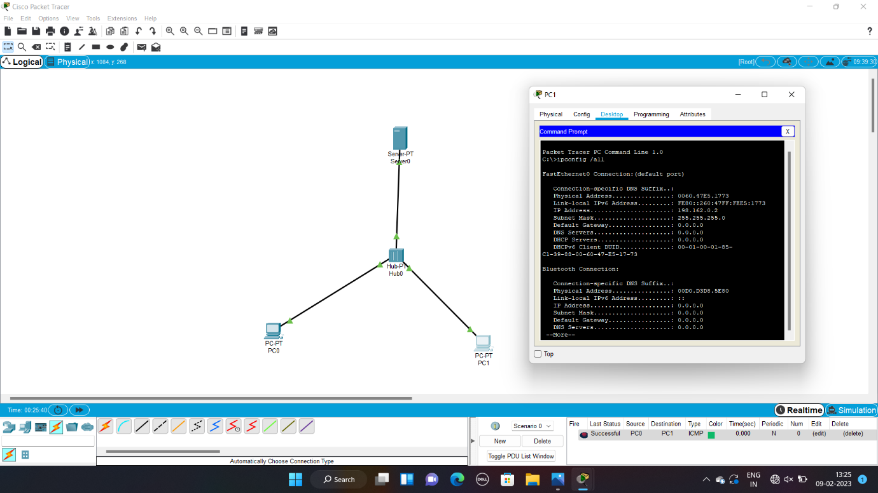

192211122

9. Data Link Layer Traffic Simulation using Packet Tracer Analysis of LLDP

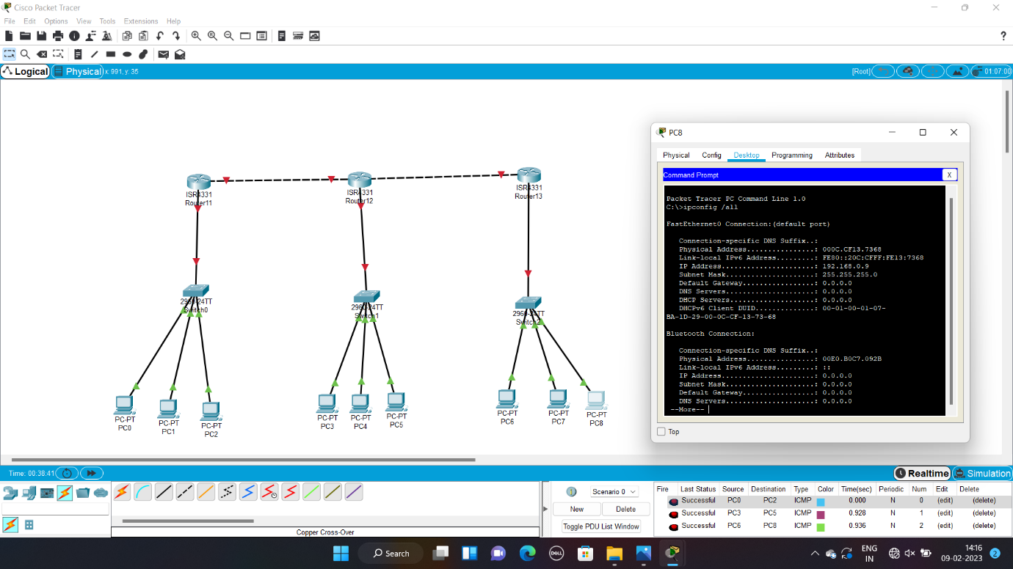

192211122

10. Data Link Layer Traffic Simulation using Packet Tracer Analysis of CSMA/CD & CSMA/CA

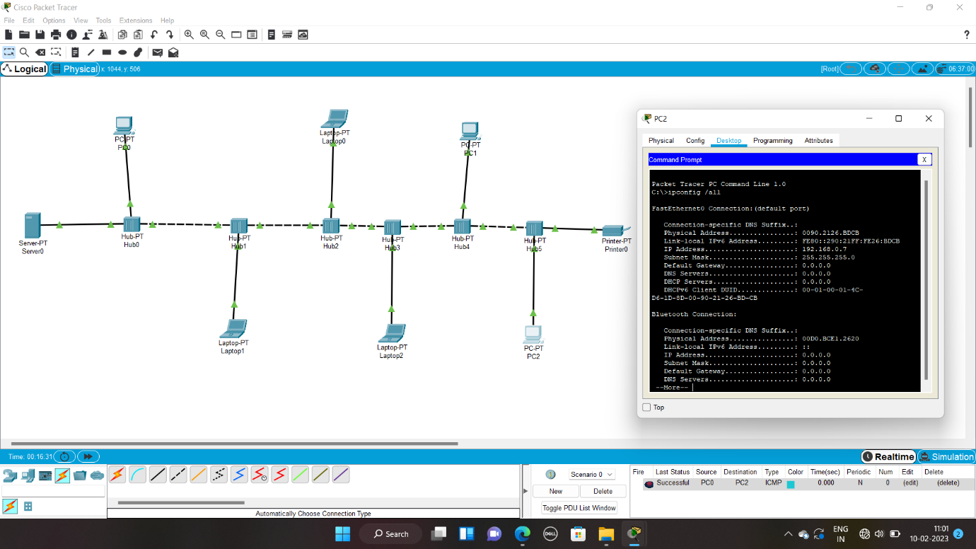

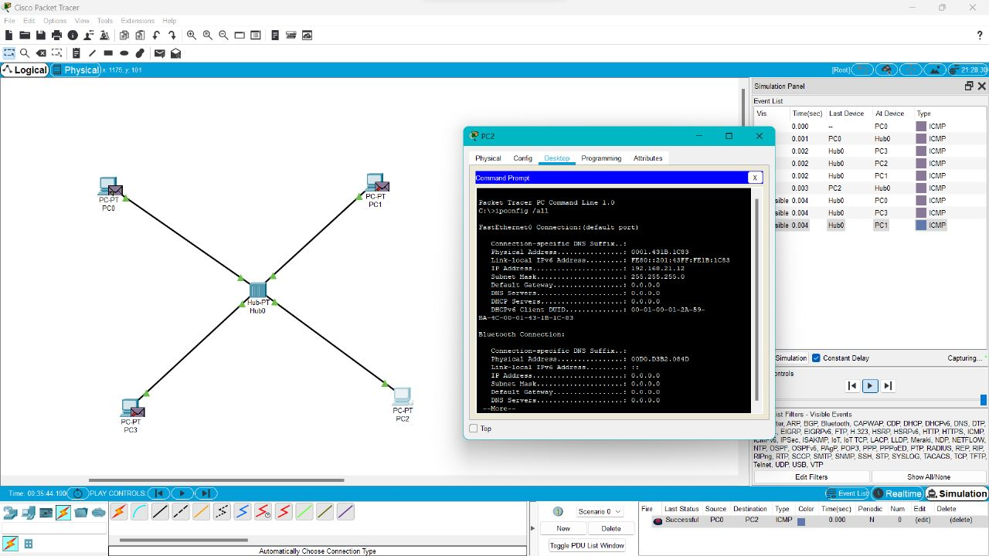

192211122

11. Implementation of Bit stuffing mechanism using C

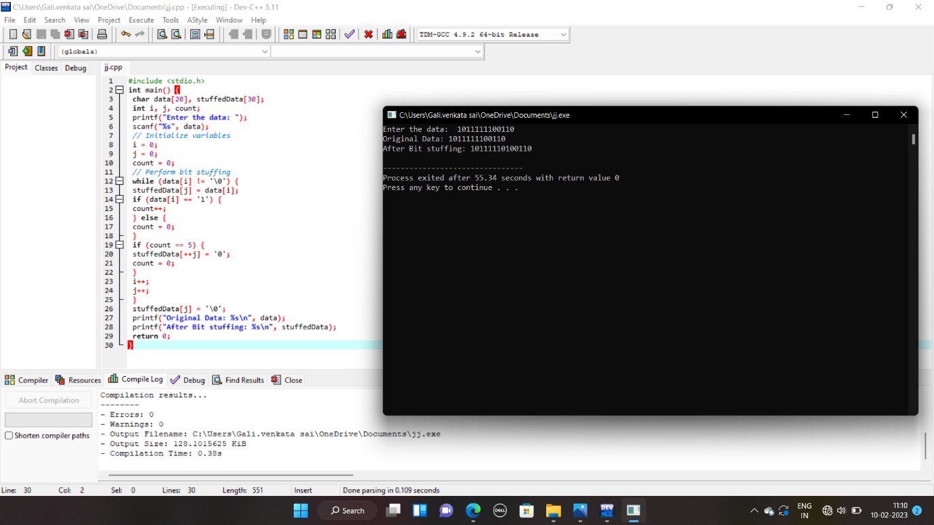

192211122

12. To design the two different network with Static Routing techniques using Packet Tracer

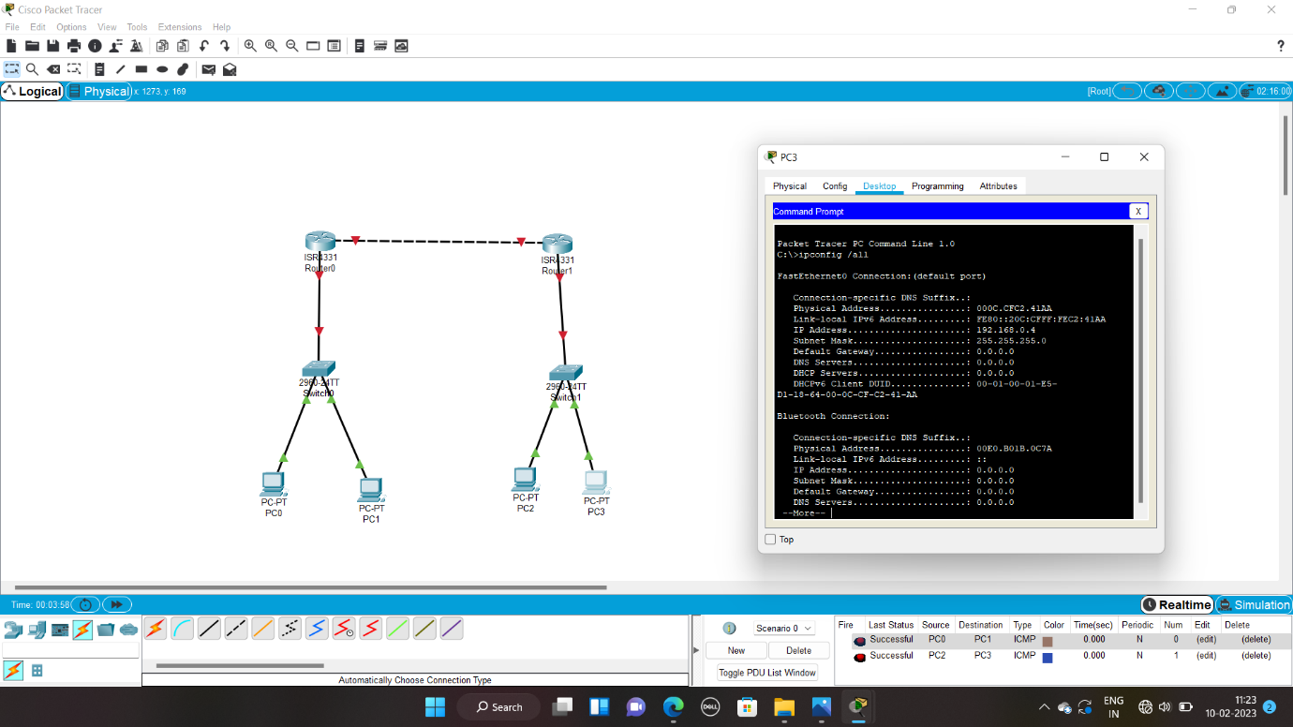

192211122

13. To design the Network with Dynamic Routing using Packet Tracer (Distance vector & OSPF)

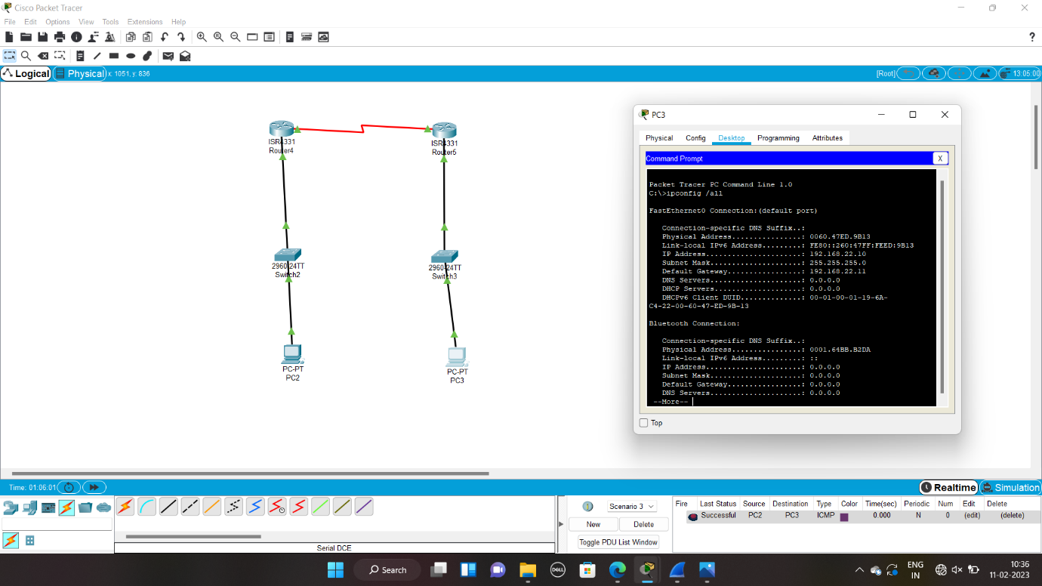

192211122

14. Design the Functionalities and Exploration of TCP using Packet Tracer

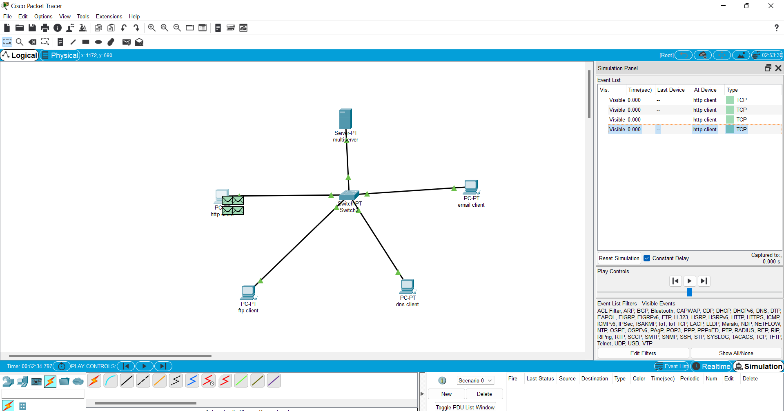

192211122

15. Design the Functionalities of Exploration UDP using Packet Tracer



192211122

16. Design the network model for Subnetting – Class C Addressing using packet tracer

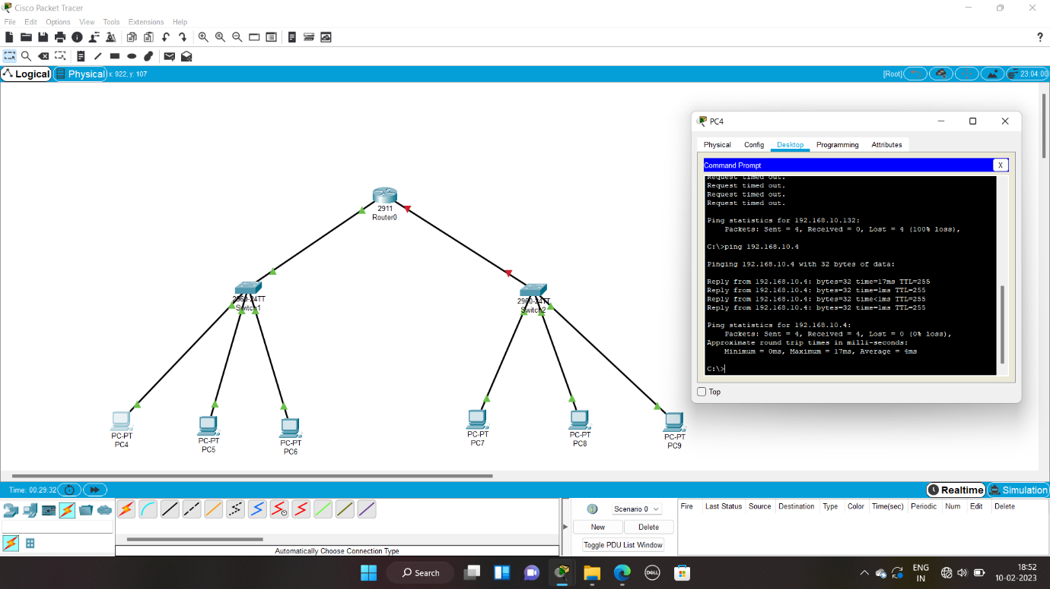

192211122

17. Implementation of server – client using TCP socket programming



192211122

18. Implementation of server – client using UDP socket programming



192211122

19. Simulating X, Y, Z Company Network Design and simulate using Packet Tracer

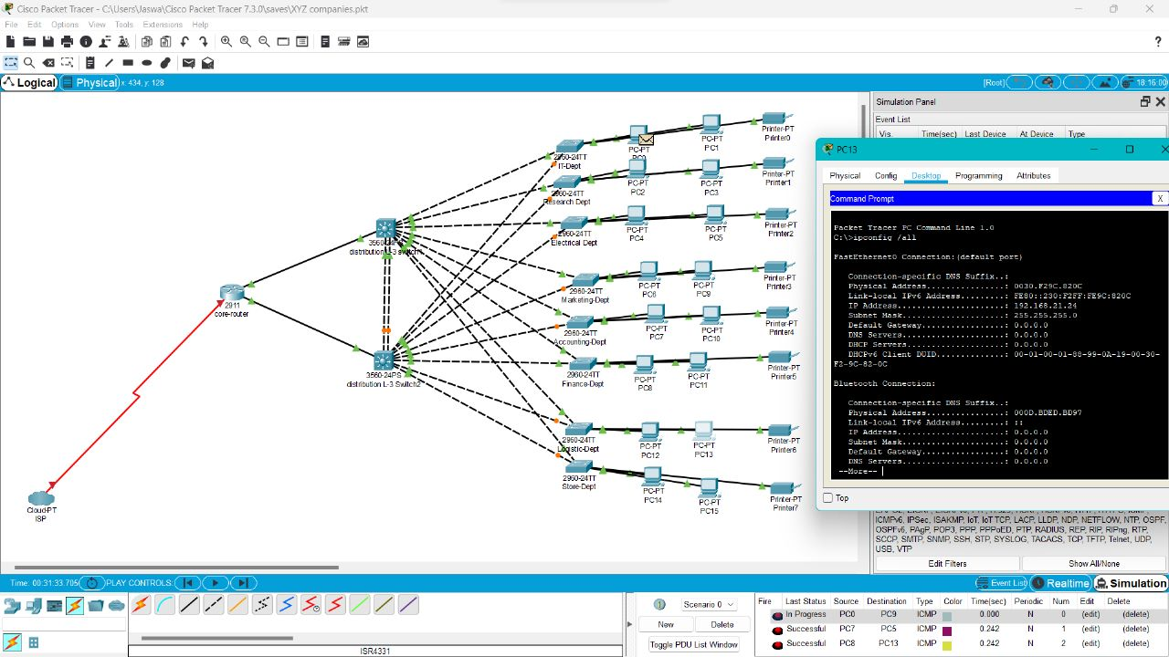

192211122

20. Configuration of DHCP (dynamic host configuration protocol) in packet tracer

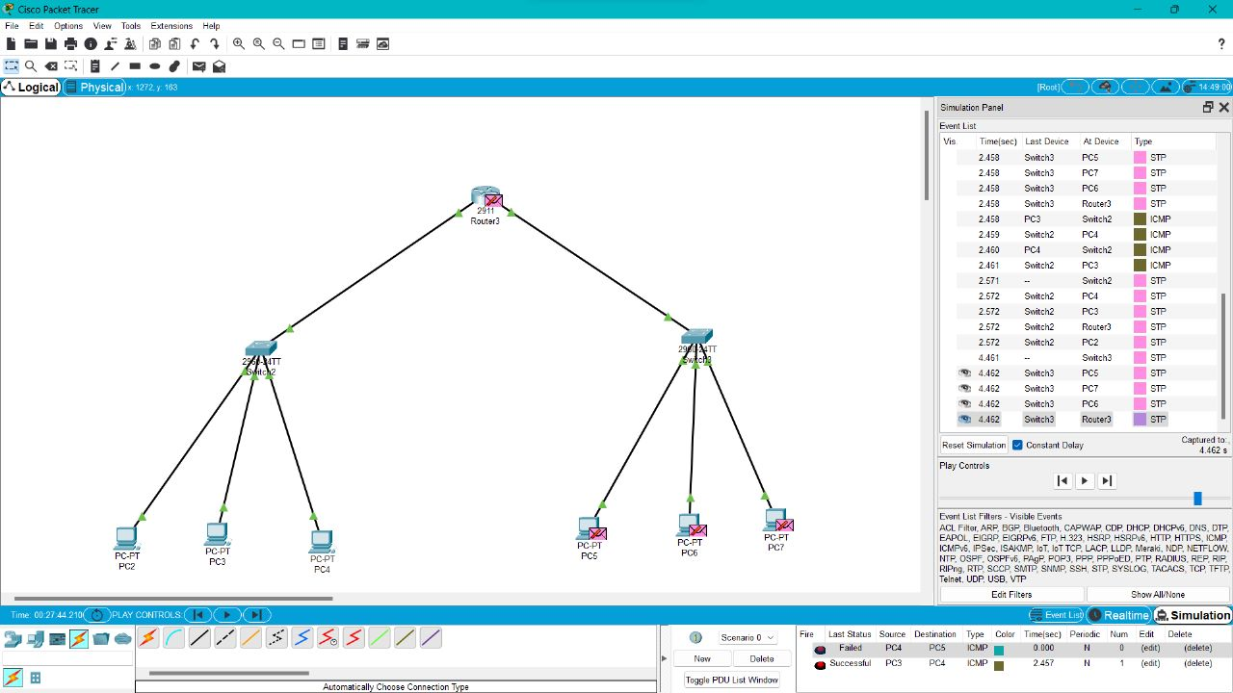

192211122

21.Make a Computer Lab to transfer a message from one node to another to design and simulate using Cisco Packet Tracer

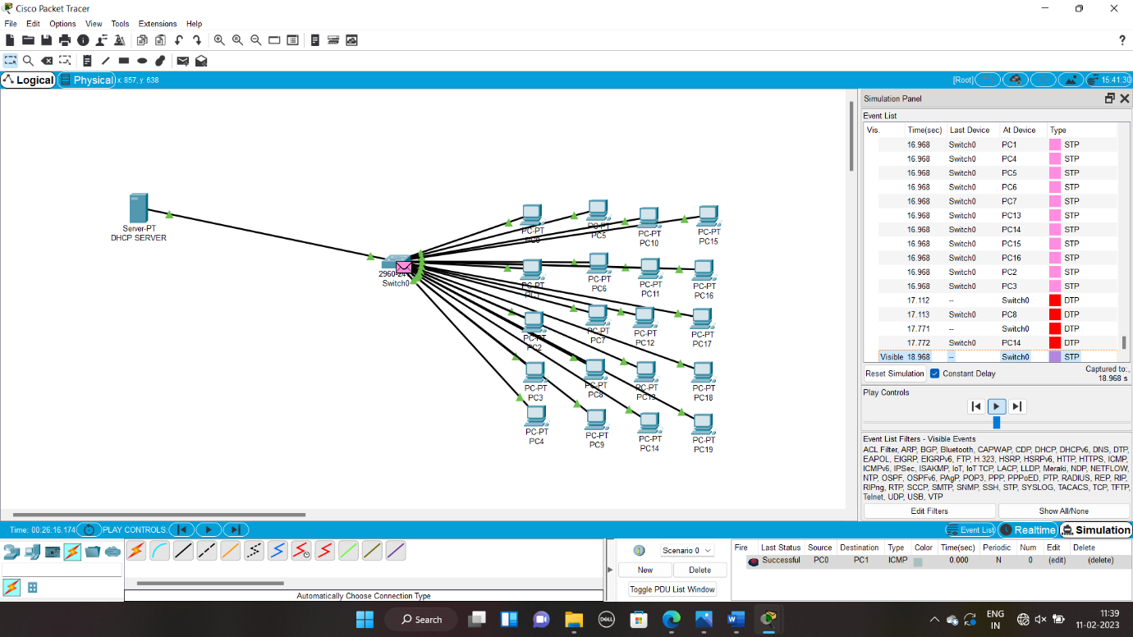192211122

22. Transport layer protocol header analysis using Wireshark- TCP

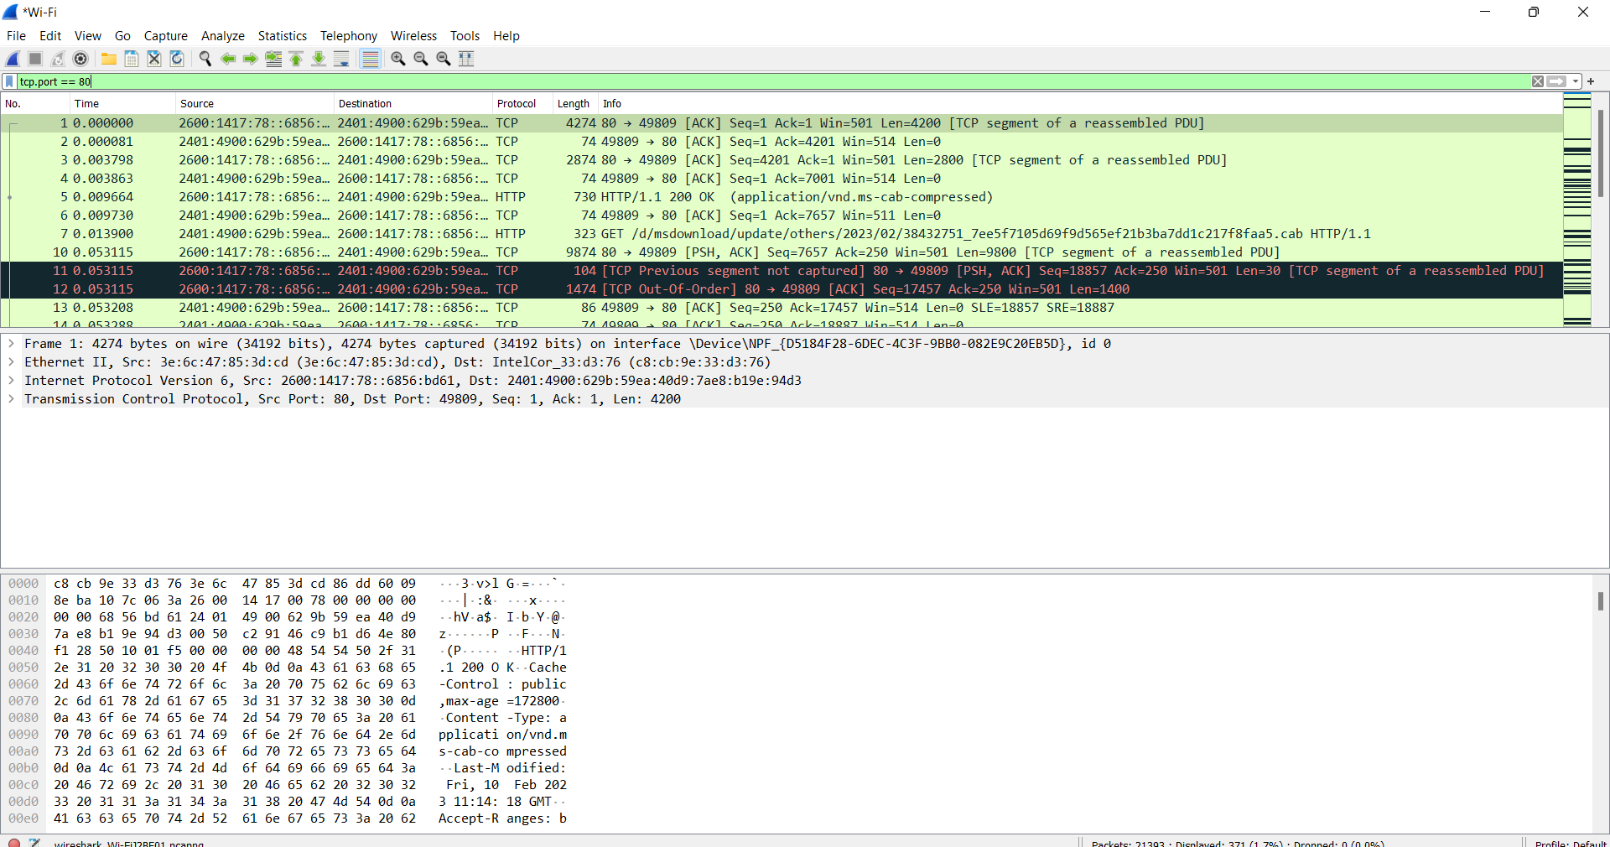

23. Network layer protocol header analysis using Wireshark – SMTP

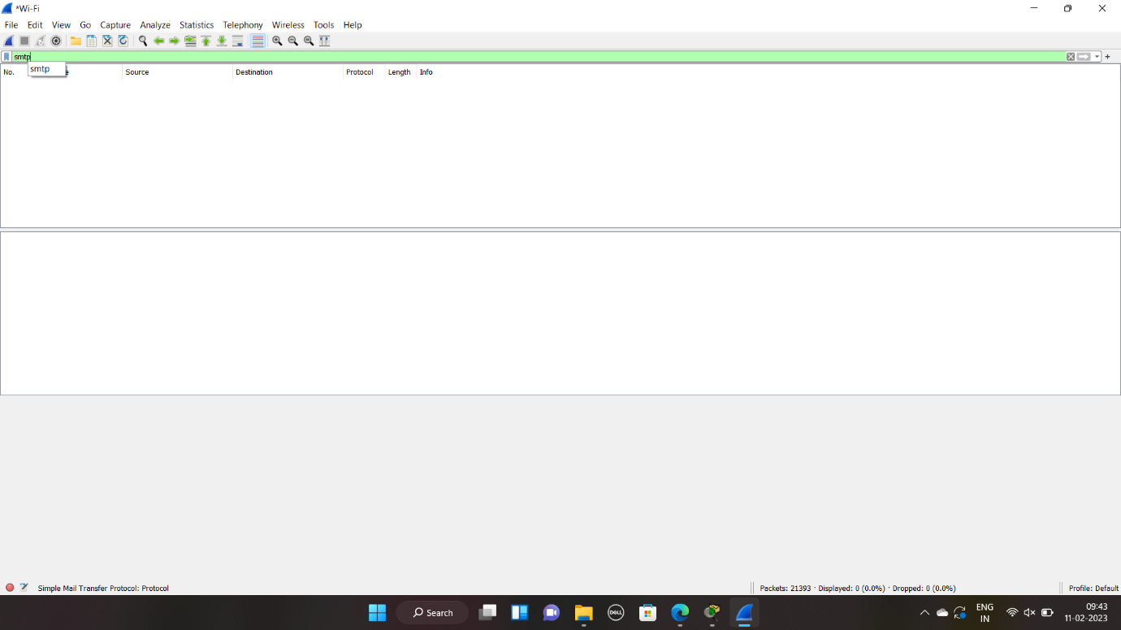

24. Network layer protocol header analysis using Wireshark – ICMP

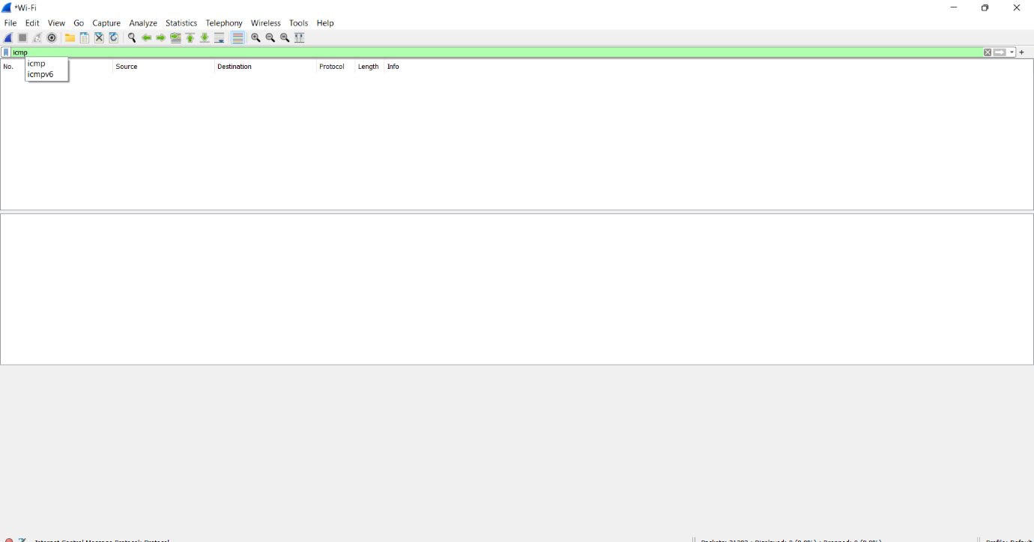

25. Transport layer protocol header analysis using Wireshark – UDP

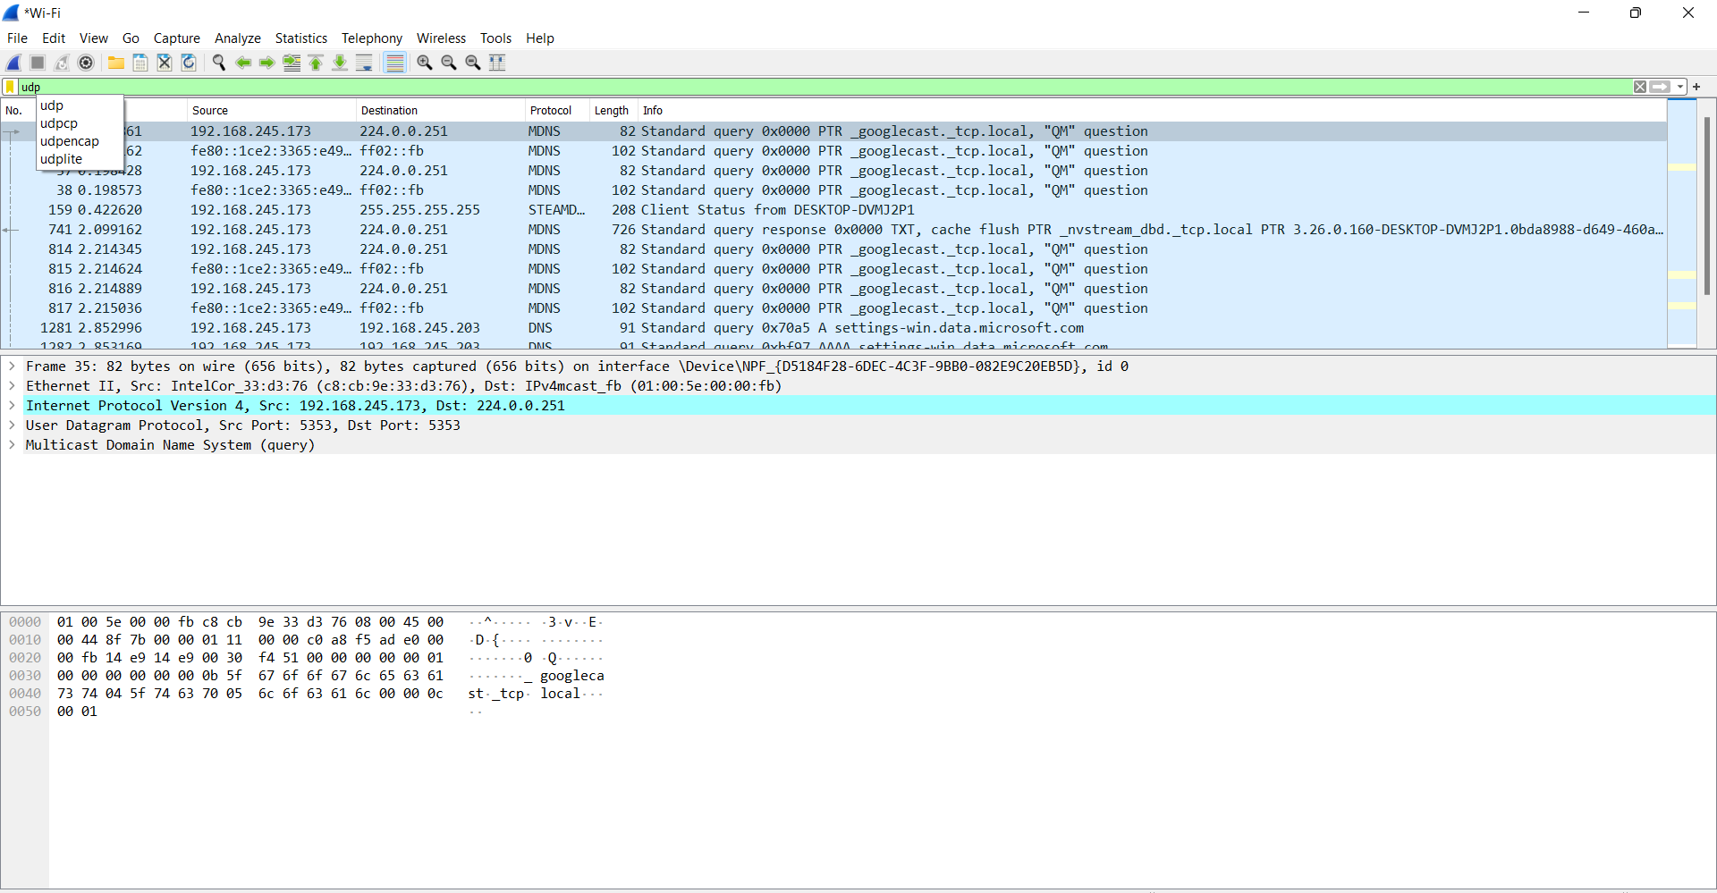

26. Network layer protocol header analysis using Wireshark – ARP

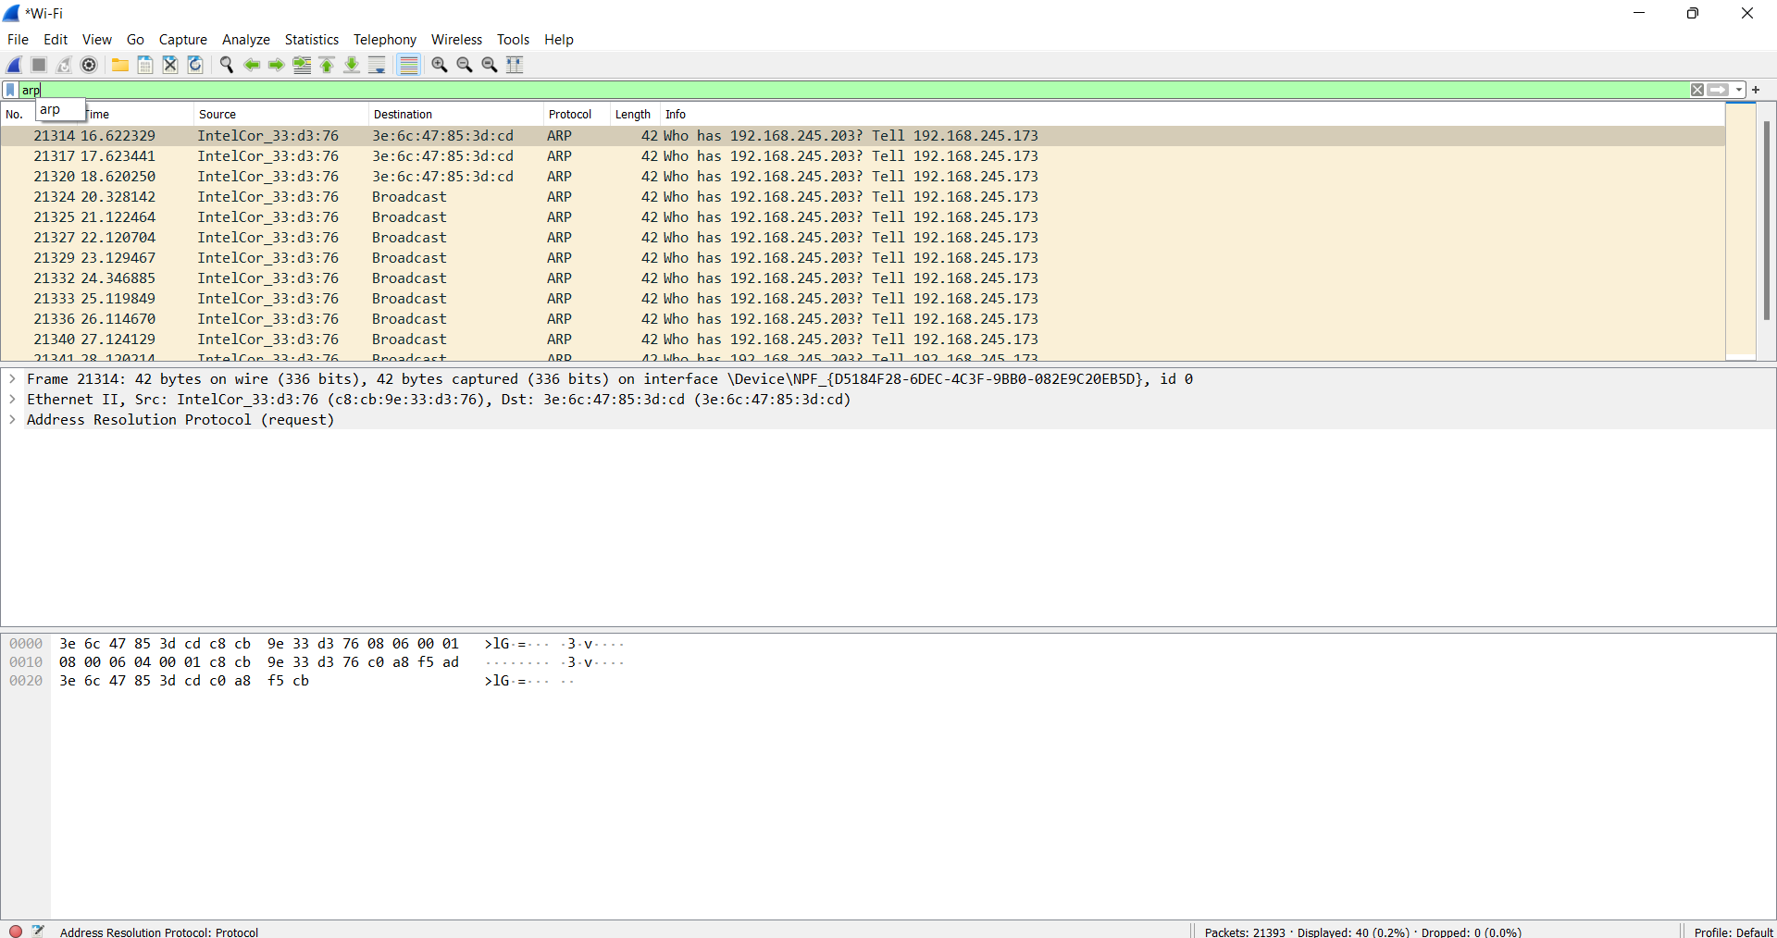

27. Network layer protocol header analysis using Wireshark – HTTP

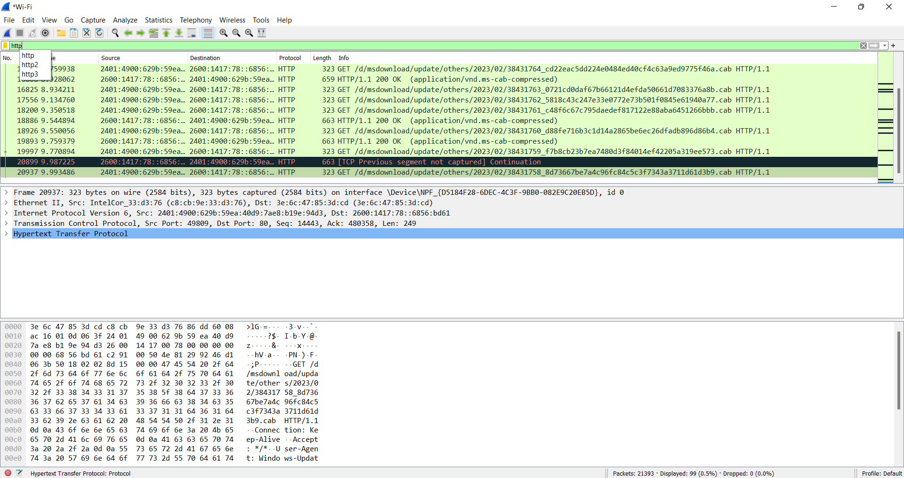

28. Demonstration of PING operation using ICMP in Wireshark

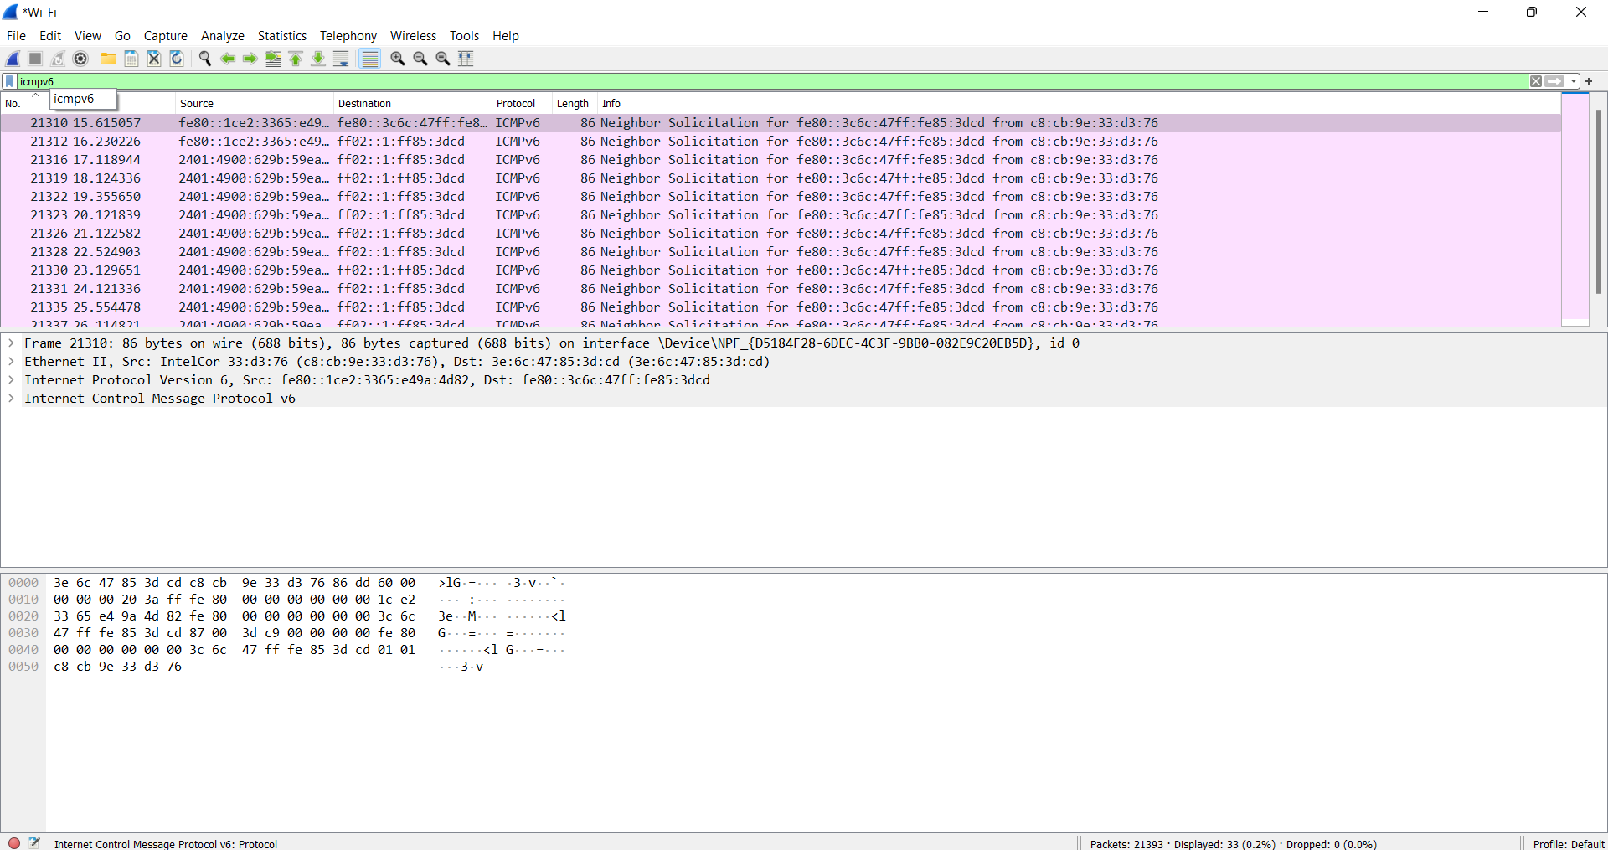

29. IOT Based Smart Home Using Cisco Packet Tracer

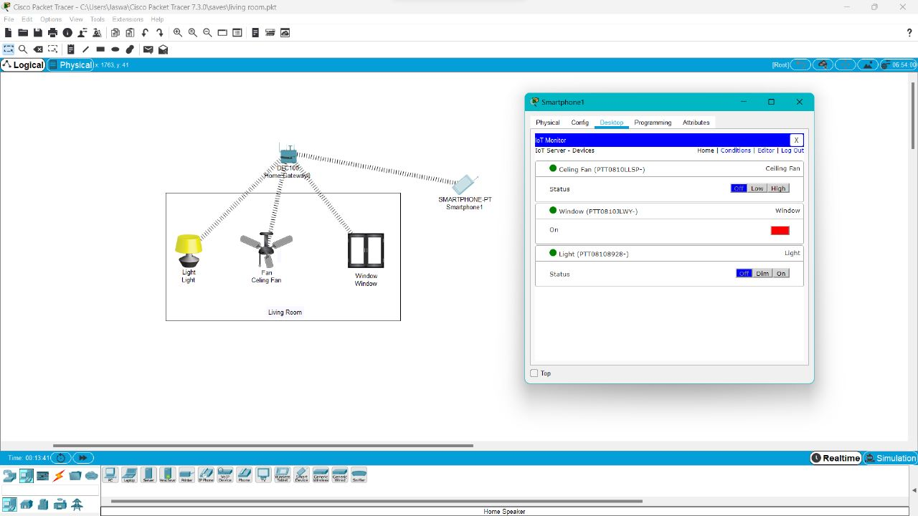

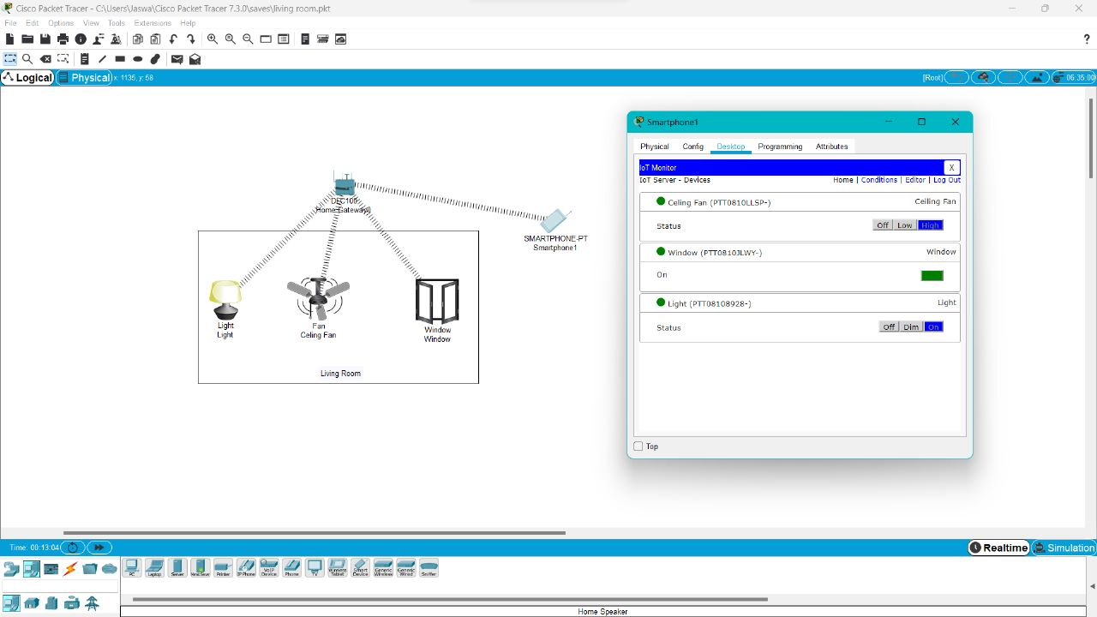

30. Smart Garden in Cisco Packet Tracer

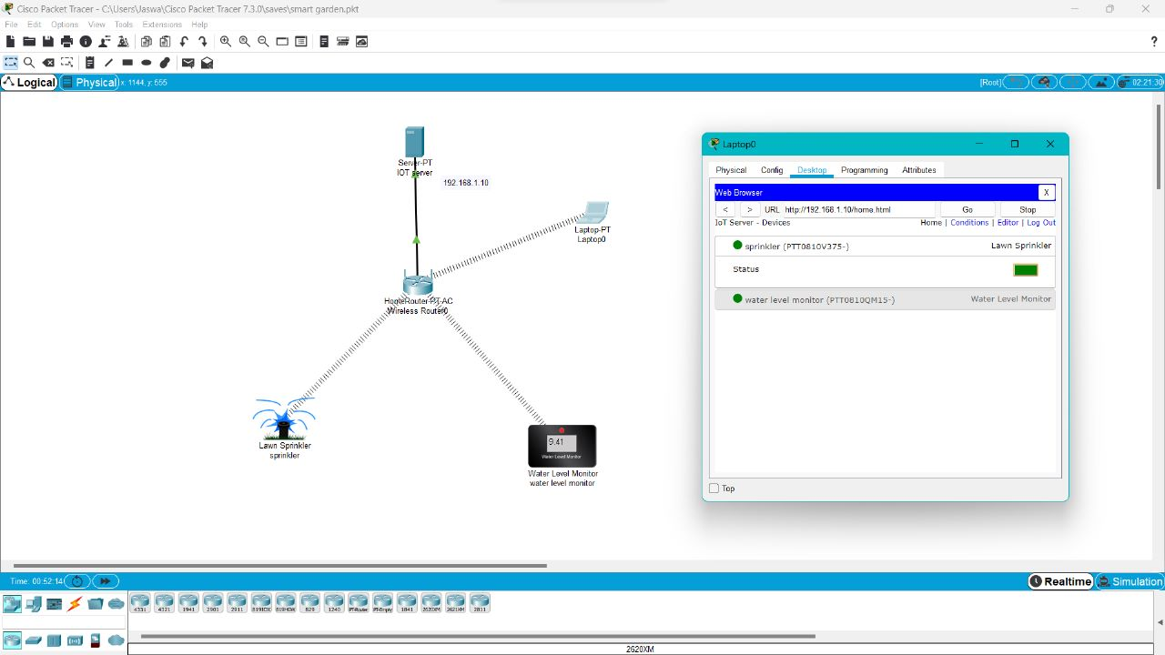

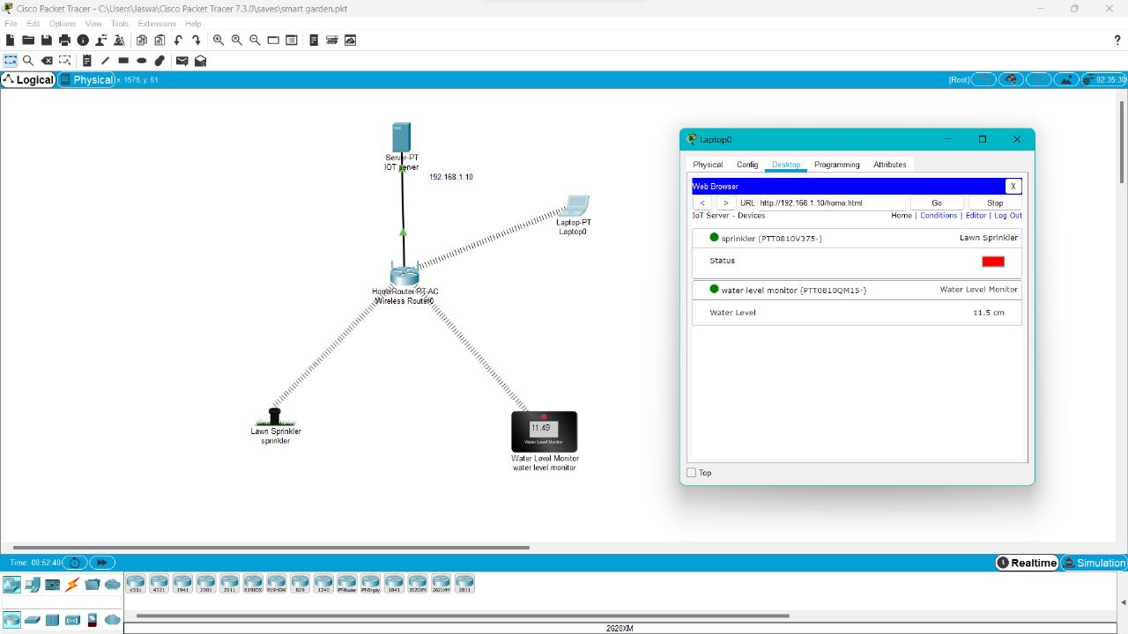

31. IOT Devices in Networking Using Cisco Packet Tracer

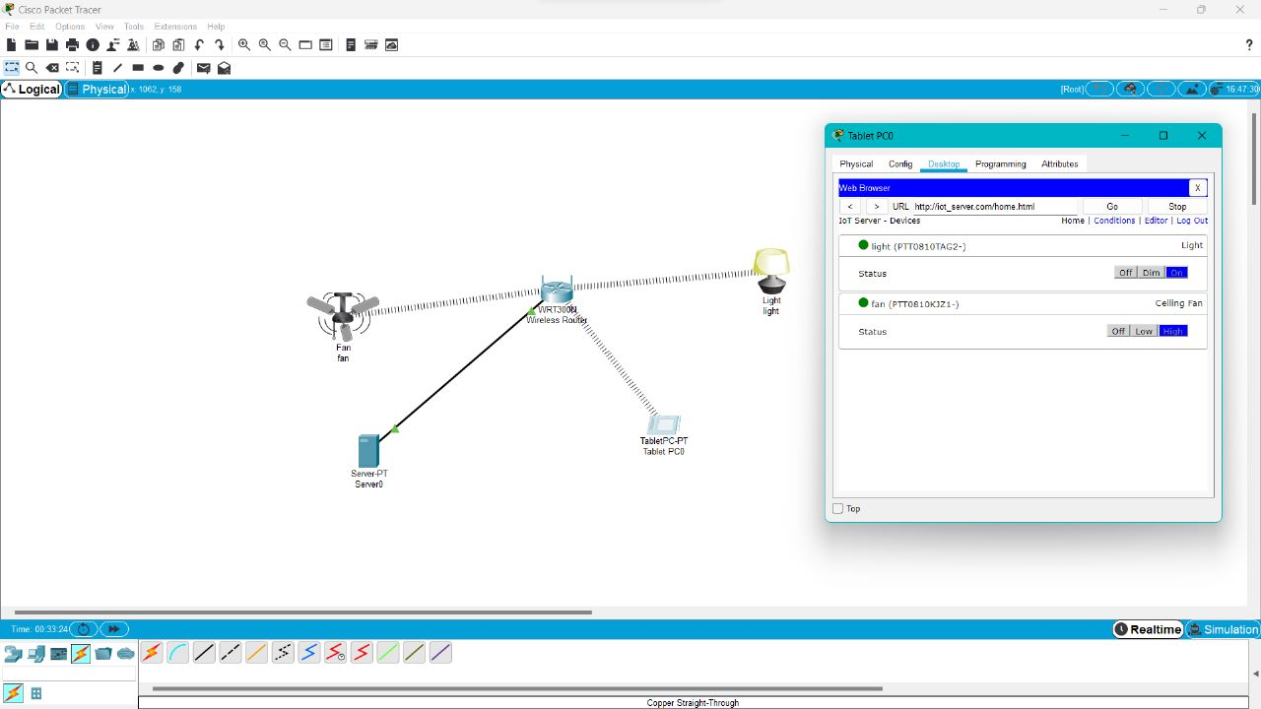

32. Control of Fan, Light, Window & Application of Using Cisco Packet Tracer

